

Long ago in the Dreamtime, Tiddalick, the largest frog ever known, awoke one morning with a huge thirst. He started to drink and drank until there was no fresh water left in the world. Soon creatures everywhere were dying and trees were wilting because of the lack of moisture. All the animals pondered about their terrible plight until a wise old wombat suggested that if Tiddalick could be made to laugh then maybe all the water would flow out of his mouth. This was a good idea the animals agreed.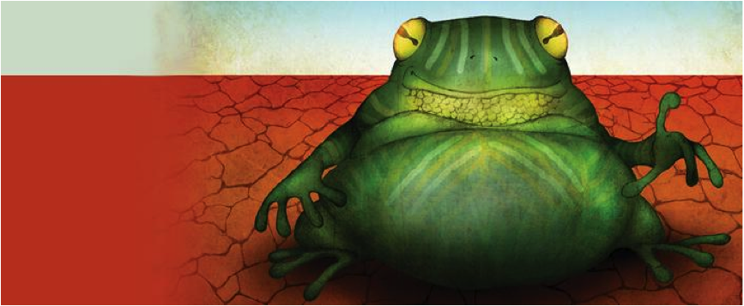

The animals gathered by Tiddalick's resting place and tried for a long time to make him laugh, but it was in vain.

The kookaburra told his funniest story, the kangaroo jumped over the beautiful emu and the lizard waddled up and down on two legs making his stomach stick out but Tiddalick was not amused.

Then when the animals were in despair, Nabunum the eel who was driven from his favourite creek by the drought slid up to the unresponsive frog and began to dance.

As the dance got faster Nabunum wriggled and twisted himself into all sorts of knots and shapes to the amusement of Tiddalick.

Tiddalick's eyes lit up and burst out laughing. As he laughed the water gushed out from his wide mouth and flowed away to replenishthe lakes, swamps and rivers again. Story by Joanna Troughton Edited by Sanchia Lane

***Tiddalick QAR***



In 

1. Who drank all the water?

_______________________________________________________________________________________

1. Why did Tiddalick drink all the water?

_______________________________________________________________________________________

1. Who told the animals to make Tiddalick laugh?

_______________________________________________________________________________________

1. Why do you think the animals wanted to make Tiddalick laugh?

_______________________________________________________________________________________

1. Why did all the plants wilt?

_______________________________________________________________________________________

1. Where did the animals gather?

_______________________________________________________________________________________

1. How did Nabunum make Tiddalick laugh?

_______________________________________________________________________________________

1. What word in the last paragraph tells you the water came quickly out of Tiddalick’s mouth? **______________________________________________________**

**Adjectives** are words that tell us about people and things. They describe colour, shape and size.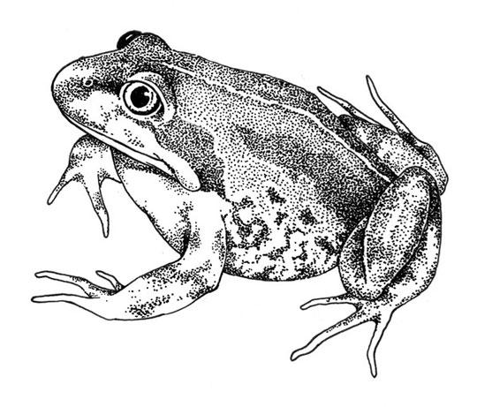

For example  *blue* car, *large* car and *three* cars.



1. Try and look for adjectives in the story that describe these nouns.
2. __________________________frog c) __________________________ wombat
3. __________________________emu d) __________________________ mouth
4. Draw and label a picture of Tiddalick on the back.

|  |  |  |  |  |
| --- | --- | --- | --- | --- |
| wide mouth | large frog | budging eyes | green body | webbed feet |